No. | Answer
Analgesic: pain reliever
Antipyretic: reduces fever
Anti-inflammatory: reduces production of prostaglandins that lead to inflammation
 | Used by the ancient Greeks and by native Americans, who chewed the leaves.
a Carboxylic acid
b Hydroxy (or alcohol)
c Ester
 | 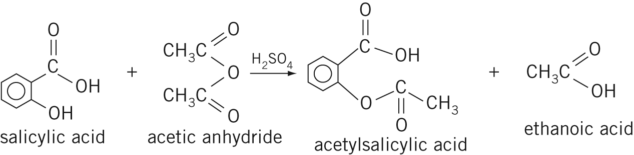
a It is a catalyst.
b It is used in many ester-forming reactions.
a The binder holds the tablet together so that it is a single, solid tablet.
b The binder must be harmless, stable and edible – starch is suitable for this.
a m(acetylsalicylic acid) = 0.325 × 10⁶ mg = 325 × 10³ g
n(acetylsalicylic acid) =
n(salicylic acid) = n(acetylsalicylic acid)
= n × M = × 138 = 249 × 10³ g = 249 kg
b The process is far from 100% efficient. Reaction is incomplete and isolation of the product is difficult because the solubility of the aspirin makes it hard to crystallise out from the reaction solution.
 | Stomach bleeding may occur. In addition, the blood is thinned too much, making it unlikely to congeal and so interfering with the clotting process.
 | Methyl salicylate (oil of wintergreen) is produced.

